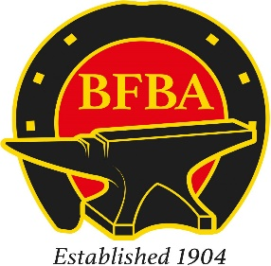

BFBA National Championships 2023
ENTRY FORM

Name: ..................................................................................
Address: .......................................................................................................................................
......................................................................................................................................................
......................................................................................................................................................
Vehicle Registration Number: …………………………………………………
Telephone Number: .........................................................................................................
Email Address: ............................................................................................................................
Name of Striker: ...............................................................................................................
Farriers’ Registration Number: ...........................................................................................
Class, you wish to enter:
Open Class ….................................
Apprentice Class …..................................

Please make BACS payable to:
Central Account DATR
Account No: 10505410
Sort Code: 16-19-26
Reference: BFBA (your name)
Please email entry forms to:
adam.cooper711@mod.gov.uk
07341 815763
mark.neal162@mod.gov.uk
07720 877839

