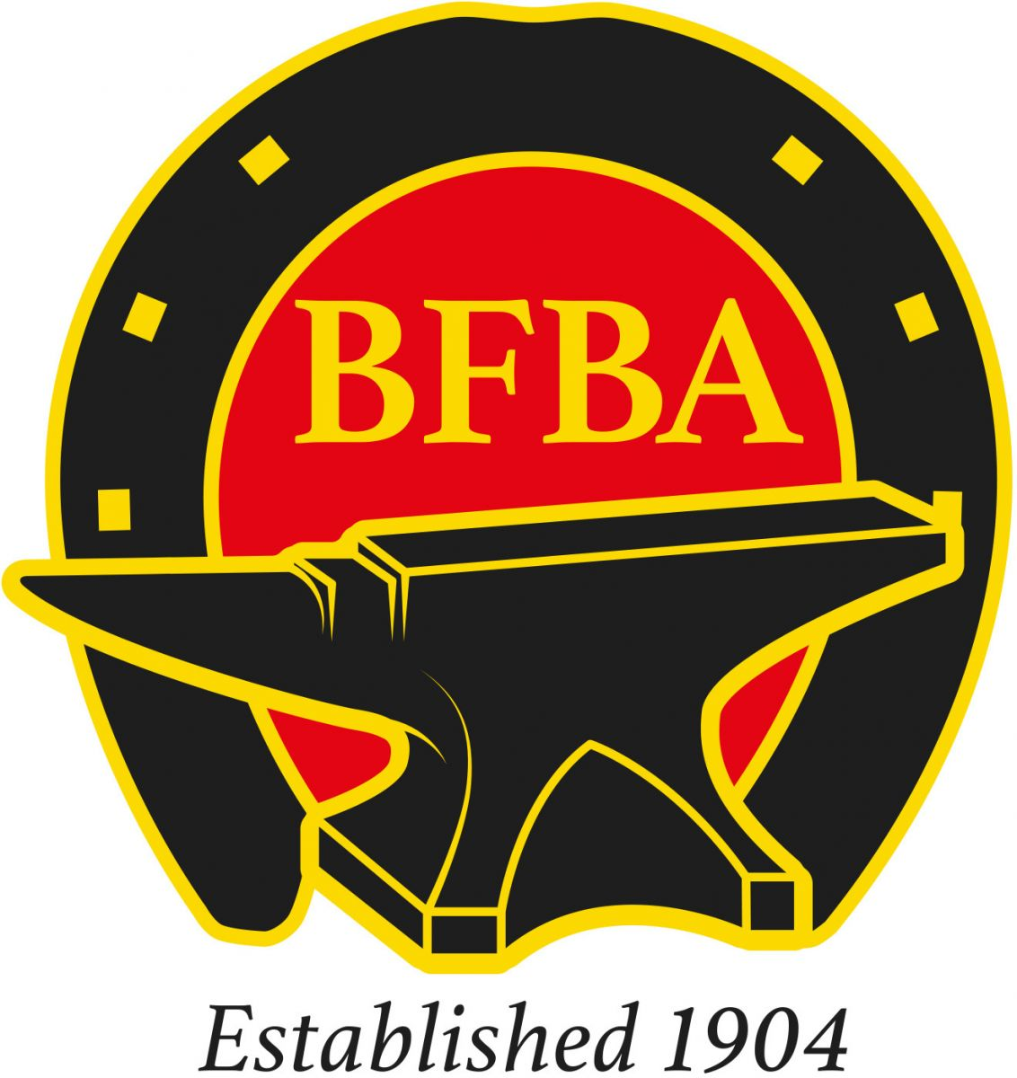

BFBA EASTERN COUNTIES BRANCH COMPETITION

12th and 13th October 2019

Venue Trinity Park, Ipswich, Suffolk, IP3 8UH
JUDGE: Robin May AWCF
Chief Steward: Stephen Britten AWCF

Work to start at 08 30prompt in the farriers’ area

**Paperless entries **

Class 1 Open Hunter – Saturday (60 mins) £30
One concave shoe applied to a foot with a Tool and Fullered specimen
Qualified farriers only

Class 1 (R) Restricted Hunter – Saturday (60 mins ) £30
Once concave shoe applied to a foot with a concave specimen
(For those who are less than 3 years qualified and not won an open class)
Qualified farriers only

Class 2 Open Heavy Horse Shoeing (60 mins) –Sunday £30
One plain stamp shoe to be applied to the foot and one fullered specimen
Qualified farriers only

Class 2 (R) Restricted Heavy Horse Shoeing (60 mins) – Sunday £30
One plain stamp shoe to be applied to the foot and one plain stamp specimen
(For those who are less than 3 years qualified and not won an open class)
Qualified farriers only

Class 3 Donkey Trimming (5mins) – Sunday £10
To trim 1 donkey foot

Class 4 Open Therapeutic Shoemaking (60 mins) –Both days £20
2 shoes to judge’s specification
Qualified farriers only

Class 5 Apprentice Therapeutic Shoemaking (60 mins) – Both Days £20
2 shoes to judge’s specification

Class 6 1st and 2nd Year Apprentice Shoemaking (50 mins) – Both days £20
No fireman/ striker
2 concave shoes to judge’s specification

Class 7 3rd and 4th Year Apprentice Shoemaking (50 mins) – Both days £20
2 fullered shoes to judges specification

Awards for

Best shod foot
Reserve champion apprentice
Champion apprentice
Reserve champion restricted section
Champion restricted section
Reserve open champion
Open Champion

Prize money 1st £40
2nd £20
3rd £10
Entries
Email: stephenbritten@hotmail.com
Text: 07825664808
Facebook: @easterncountiesfarriers

Payment
S j Britten
20-62-68
03946738

Recommended hotel
Premier inn
Ipswich south east
3 Augusta Close, Ransomes Euro Park, Ipswich IP3 9SS

from £50 a night

