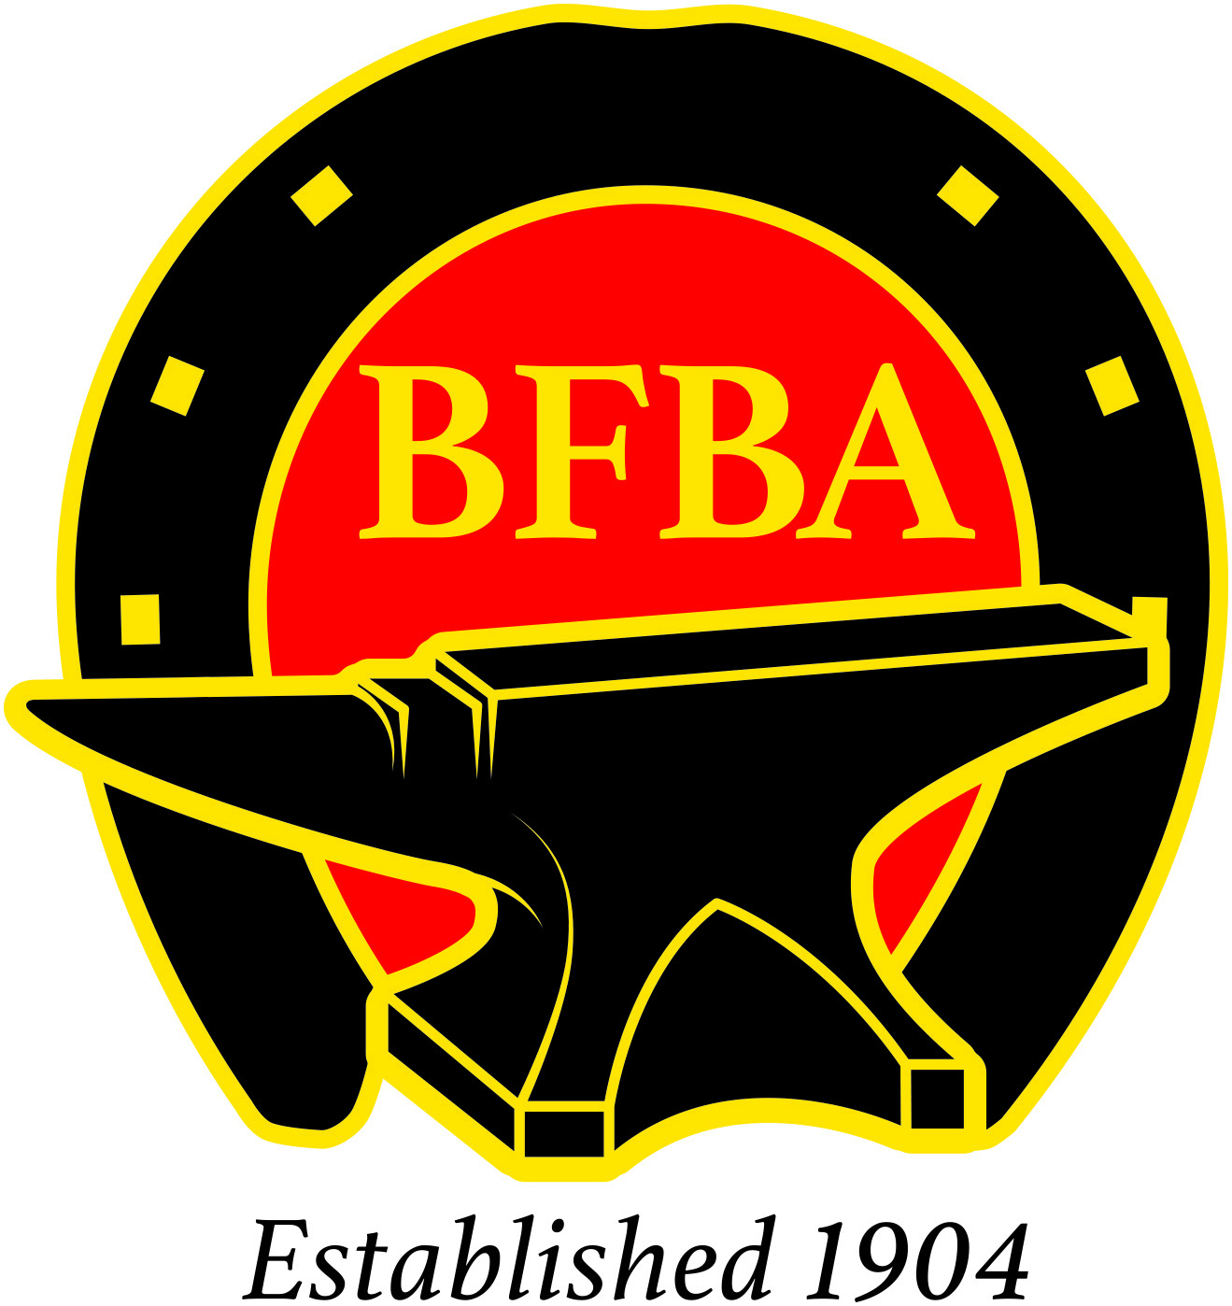 | RULES FOR THE  BFBA NATIONAL CHAMPIONSHIP

1. The 'class' to be named the 'BFBA National Championship'.
2. The 'class' to be open to those competitors with 1st, 2nd or 3rd placings in Open
National and County Competition including the BFBA Lockdown League during
the previous three years.
3. Every competitor in the Championship to be a current year BFBA
member. A list of competitors and their strikers will be submitted to the BFBA office prior to the start of the Championship in order to check entry eligibility.
4. Two Judges (1 for feet, 1 for shoes) to be chosen from the WCF List of Approved
Judges.
5. The BFBA Chief Steward to be in attendance in order to ensure that the class is
run in accordance with the rules. Expenses (travel/accommodation if required)
to be paid by the host Society/Organisation.
6. The host Society/Organisation to provide a minimum of £500 prize money to the
Champion, £200.00 to the Reserve Champion and prize cards to the top eight.
7. The New Century Cup to be awarded to the Champion, The Frank Moorcroft
Memorial Trophy to be awarded to the winner of the Best Shod Foot
BOTH TROPHIES TO REMAIN THE PROPERTY OF THE BFBA.

Additional Awards:
WCF Silver Medal
BFBA (NAFBAE) Silver Medal to the Reserve Champion.
8. Entry fees kept by the host Society/Organisation.

9. The class to follow the set format which is:
Each competitor to make, fit and nail on a ¾” fuller shoe, toe clip front and quarter clipped hind on a foot allocated.
Make one Heavy Horse Hind Shoe from 1” x ½” with Calkins and plain stamped nail holes hammer drawn toe clip, size to suit.

and

One deep seated fullered bar shoe 1” x ½” – 6” wide 6 ½” long.
No implement striking another in the making of the clip, no flatters
Time limit 90 minutes No Striker or Fireman allowed.

