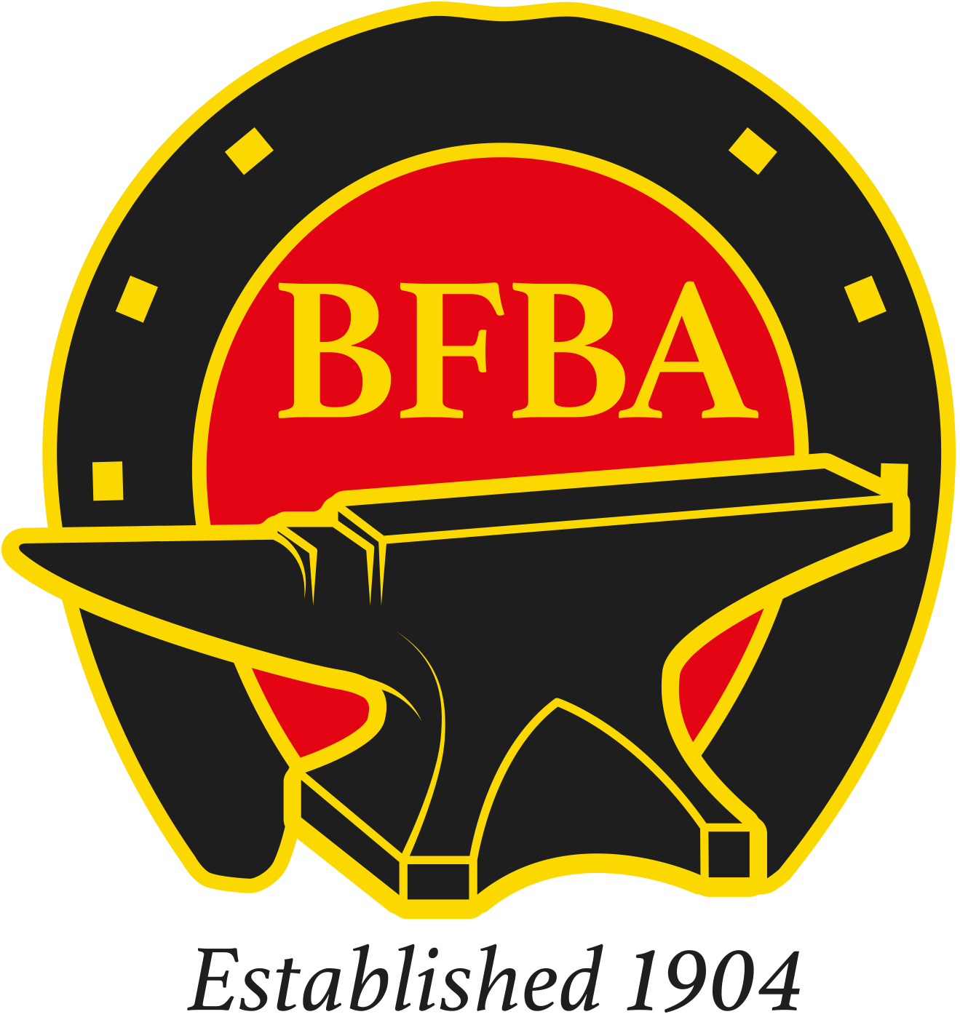 | RULES FOR THE BFBA NATIONAL APPRENTICE CHAMPIONSHIP

1. The 'class' to be named the 'BFBA National Apprentice Championship'.
2. The 'class' to be open to those competitors who are officially recorded as
1st, 2nd, 3rd or 4th year apprentices with the Farriers Registration Council.
3. Judge to be chosen from the WCF List of Approved Judges.
4. The BFBA Chief Steward to be in attendance in order to ensure that the class is
run in accordance with the rules. Expenses (travel/accommodation if required)
to be paid by host Society/Organisation.
5. The host Society/Organisation to provide a minimum of £100 prize money to the
Champion, £50.00 to the Reserve Champion and prize cards to the top eight.

Additional Awards:
WCF Bronze Medal to Champion
BFBA (NAFBAE) Bronze Medal to Reserve Champion
6. The J & A Ferrie WCF Shield to be awarded to the Champion,
THE TROPHY TO REMAIN THE PROPERTY OF THE BFBA.
7. Entry fees to be kept by the host Society/Organisation.

8. The class follows the set format which is:
Each apprentice competitor to make:

Front Straight Bar Shoe from 7/8” x 3/8” - 15 ½” fullered concave section
and a

Front Deep Seated Open Shoe plain stamped from 1” x ½” – 11 ½” flat section

Time limit 60 minutes
No Striker or Fireman allowed

